**DE Assignment Theoretical Design**

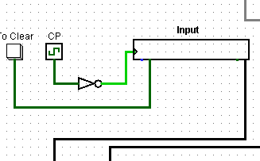

Here the keyboard takes input in English letters or Number and then it gets converted into its ascii value which consists of 7 digits here “To clear” is used to clear the input value whenever the user wants to by clicking it.

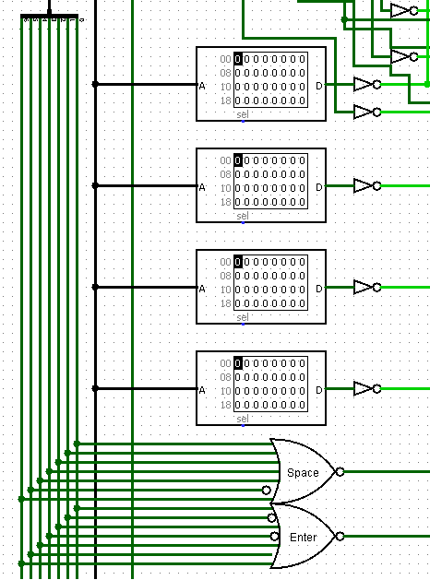

Whenever there is blank space in the output of morse code(represented by a cross in the truth table) we put 1 for its corresponding binary in the ROM.

Now according to the corresponding ascii value of space and enter we have provided the required gates.

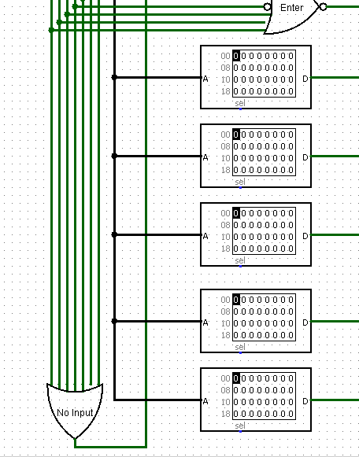

Whenever there is a dot(.) we have put value in ROM as 1 and 0 otherwise. Now in the case of 0, it checks with the earlier set of roms that if that is 1 it means it is a blank space else it is a dash(-).

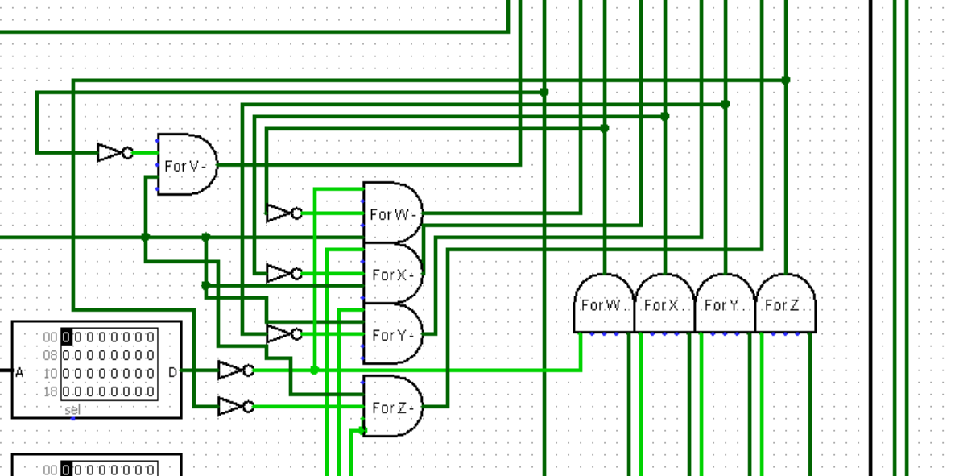

As we can see, by using the and gates we make sure that the blank space is not displayed as a (.) or (-).

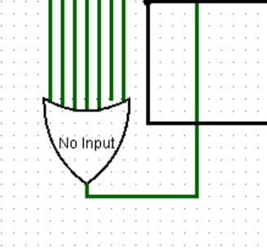

And the No Input OR gate is used to determine the initial state and the last state when there is no input given. If this is 0 it means that there is no input provided via the keyboard and hence there is no output.

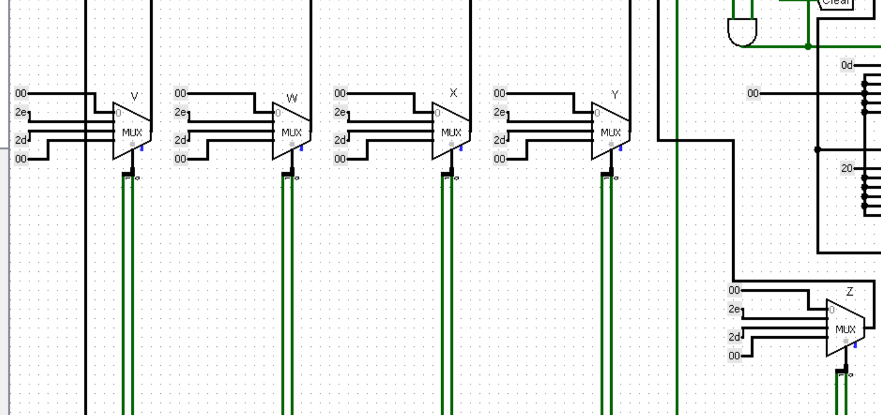

With the help of these 5 Mux (multiplexers) we can determine the output for dot and dash by providing the ascii values of it ie. ( 2e for ‘-’ and 2d for ‘.’ )

And 00 for the case both the selection lines are 0. Which will represent no output for the Output display (TTY)

Here if the selection line 0 is activated it will activate 2e for the output and 2d if selection line 1 is activated.

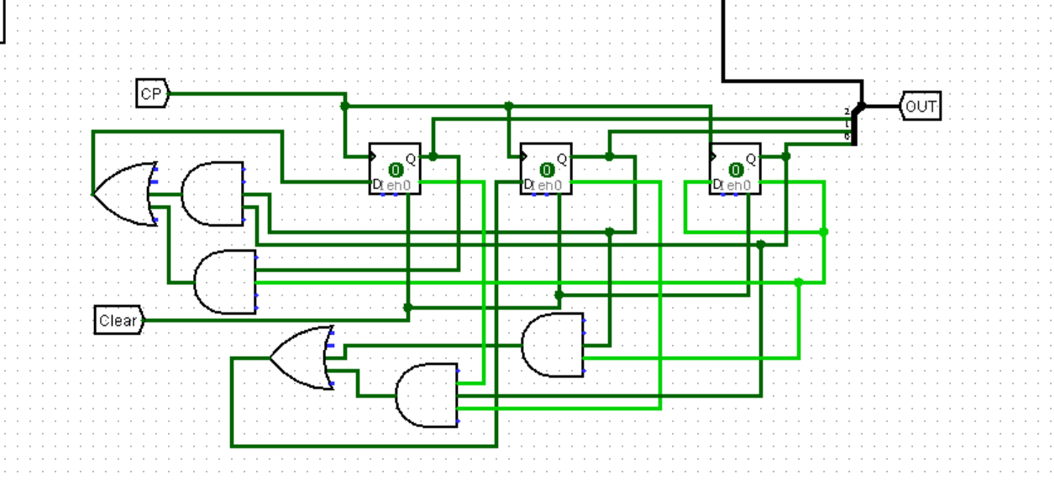

This is the Synchronous counter from 0 to 5 which helps us to display the output for the given input. (we use it till 5 because there is the possibility of outputting a maximum of 5 .’s or -’s)

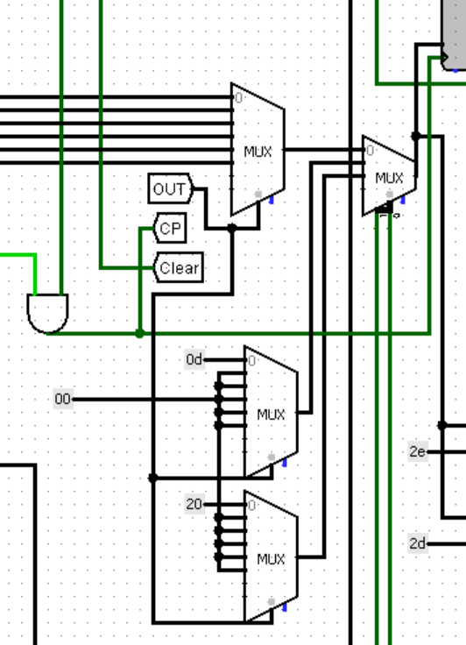

The AND gate is connected to the NO input OR gate. It is connected in such a way that if there is No input given via the keyboard then the clock pulse wont reach till the display or the counter. So it wont display blank lines in the TTY display.

The later 2 Muxs are meant for Space and Enter. If the input is enter then it would activate the the top mux (the one that contains 0d as the first input).

And would activate the second mux (the one that contains 20 as the first input) if the input is space.

If the input is neither space nor enter then it would normally use these muxs as the input.



All of that is controlled by this mux 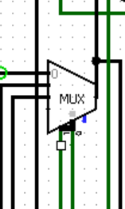 . If the selection line is 00 it means that it is a Normal Input, 01 means Enter and 10 means Space.

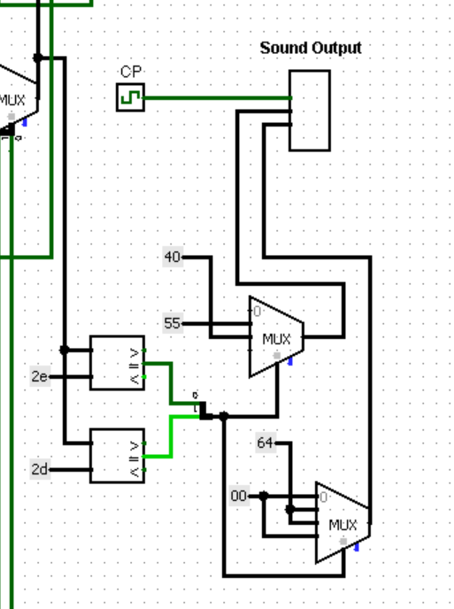  
  
This is meant for Sound Output. By using the comparator we can find if the output is a ‘.’ or a ‘-’ and accordingly we can output the sound.

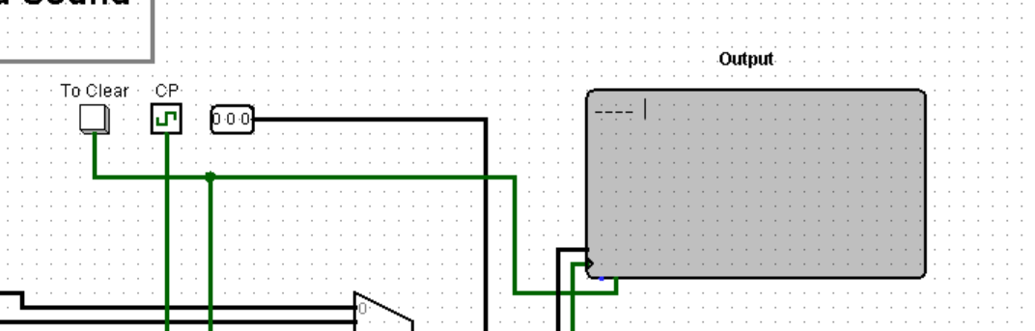

This is the TTY Display(Output), which displays the converted Morse Code.

And to Clear Push Button helps us to Clear any kind of Previously Displayed Output. It also resets the Counter to 000.

The Clock Pulse Provided here is 1 tick for both High and Low compared to the Clock Pulse Provided for Input (Keyboard) which was 6 ticks for both High and Low.

This is done to ensure that the Output we get is complete because for numbers the output is going to go till 5 characters ( . or - combined).

And the 6th tick is for a space to differentiate between different Inputs.